**IT2120 - Probability and Statistics**

**IT24104072 – Wasala W.L.M.P.D**

**LABSHEET 10**

R Script

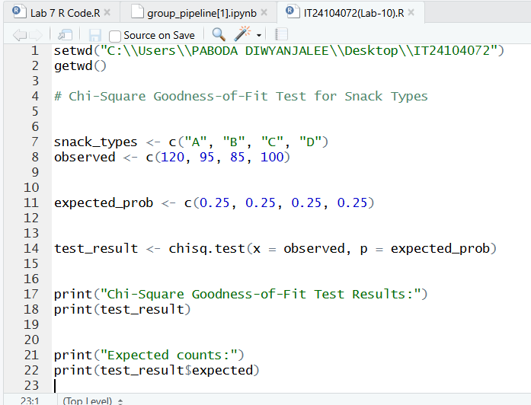

Answers

Final Data

